**TUGAS SIMPLE QUERY MYSQL (BAGIAN 2)**

**MOHAMAD ARDIANSYAH ROFII**

1. 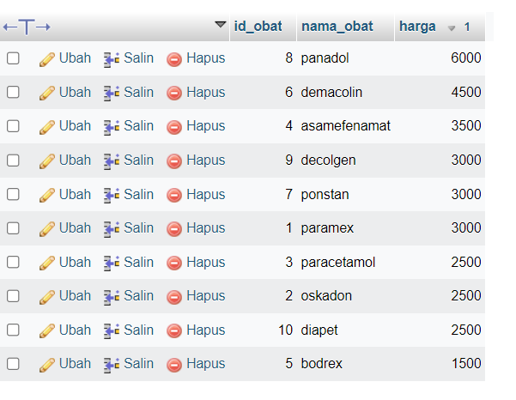**SELECT * FROM `obat` ORDER BY harga DESC**

1. **SELECT * FROM `obat` ORDER BY harga ASC**

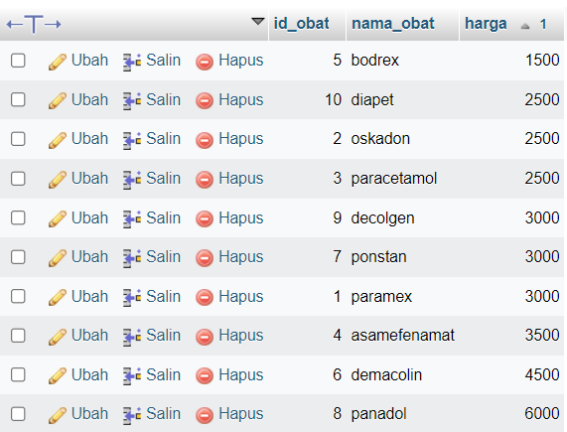

1. **SELECT * FROM `obat` WHERE nama_obat LIKE '%OL%'**

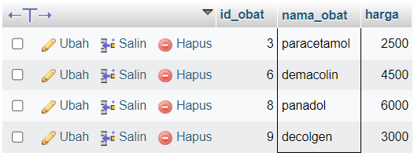

1. **SELECT * FROM `obat` WHERE nama_obat LIKE '%EX%'**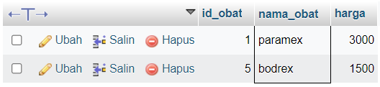
2. **SELECT id_transaksi, SUM(total) as total FROM `transaksi` GROUP BY id_transaksi**

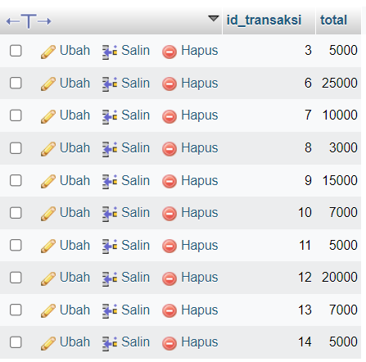

1. 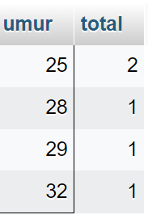**SELECT umur, COUNT(umur) as total FROM `pembeli` WHERE umur <= 40 GROUP BY umur**
2. 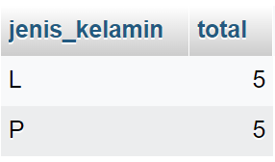**SELECT jenis_kelamin, COUNT(jenis_kelamin) as total FROM `pembeli` GROUP BY jenis_kelamin**
3. 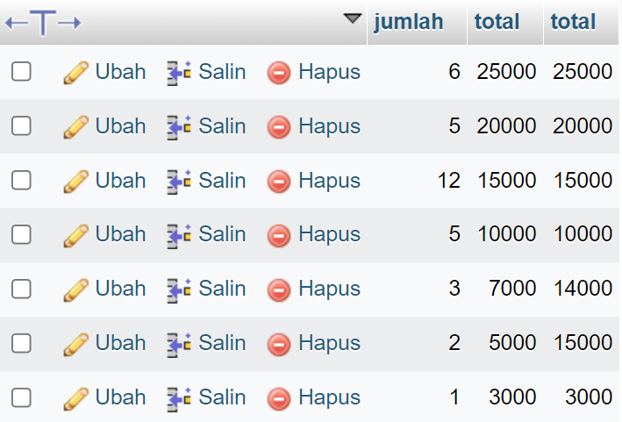**SELECT jumlah, total, SUM(total) as total FROM `transaksi` GROUP BY total DESC**
4. 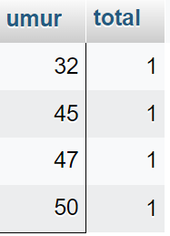**SELECT umur, COUNT(umur) as total FROM `pembeli` WHERE umur <= 50 AND umur >= 30 GROUP BY umur**
5. 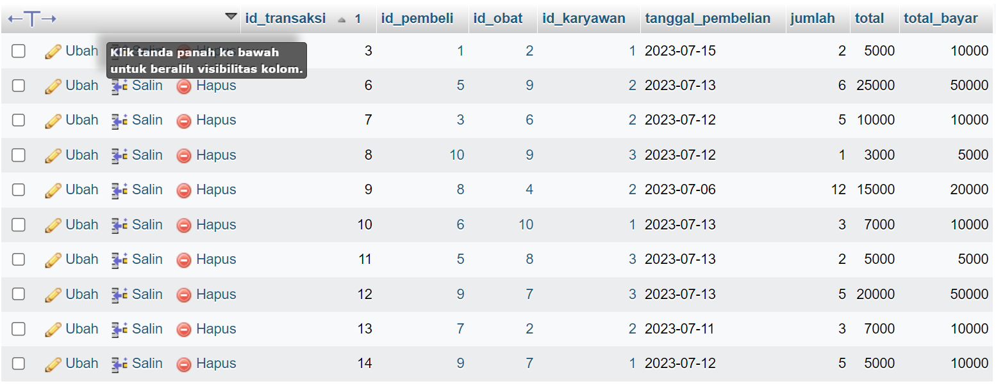 **SELECT * FROM `transaksi` ORDER BY id_transaksi ASC**